Genesis 2 & 3
Kindergarten & 1st Grade

GATHERING
Welcome & settle in. A time to get kids warmed up to each other and to the story. Also a good opportunity to help kids feel like they belong here by asking questions about their lives. By helping them know that they belong, they experience what we are teaching them.

NAME GAME
As you get started, make sure you know everyone’s name. Play a name game if don’t know them all well yet. With a ball (or any object), tell them that only the person holding the ball gets to talk. When they have the ball, they are going to say their first name and another word that starts with the same letter as their name. You start first to show as an example, then hand the ball to the person next to you. Once everyone has gone around, try going around faster, using the same word to go with each name. Do it a third time a little faster. Then on the fourth time, the person holding the ball doesn’t say their own name and word, they let the other kids try to remember their name and word. If someone is a bit scared, consider not forcing them into it. You could just find out their name and let them watch.

WHAT I’M GRATEFUL FOR
“Today we are going to learn about how God created the whole world. As we begin, let’s go around and say something you are grateful for. Something that you really like about the world. Maybe you really like your pet or your family or a friend or going to the lake or taking a walk in the woods. Who’s ready to say what they are grateful for?”
WHAT DO YOU KNOW?
This will help get you started talking about the story but it is also a chance for kids to talk and feel like they are a part of the group. The more they can feel heard and that what they say is valued, the more we are showing them God’s love and inclusion. Take your time with this section even if it starts to get off track.
“Does anyone know something about the story of Adam and Eve and the Garden of Eden?” Give them time to shout out anything they know about it, if they do.
“In the Bible there is a story about how God created the whole world and everything it. What are some of your favorite things about our world?” Let them answer – could be things like family and friends. You can give them prompts like, “What is your favorite animal?” “What is your favorite thing to do outside?” or “Do you have any pets?”
“God created everything! Including people, who he gave really smart brains to then create other things like houses and umbrellas and spaghetti. What are some of your favorite things that people make?”
“We don’t know how God made everything, but we do know that God made the world and us because God loves us. And we also know that God created us to love God and love each other.”

TELLING THE STORY

SPARK STORY BIBLE
If you are reading from the Spark Story Bible, it’s pages 8-13 and 14-19.

GET TO THE POINT
- “What did God create in this story?” (Adam & Eve, animals, plants. Everything!)
- “What job did God give to Adam and Eve to do?” (Take care of God’s creation and name the animals.)
- "What did Adam and Eve do that they weren't supposed to do?" (Eat the forbidden fruit of the tree in the middle of the garden.)
- "How did God feel about that?" (Sad)
- "How did God help them at the end?" (Made them clothes and promised to be with them in the big hard world)

REINFORCE
DIY STORY BIBLE
What you’ll need:
Coloring page for the week
Three-prong folder for the year, one for each child
Markers and/or Crayons
Let kids make their own story Bible this year! Each week have kids color a page that matches the story. At the end of the year, they will have their own story Bible that they created.
When you print copies of the coloring page, make sure they are three-hole punched along the side. When they are finished coloring their page, put it into their three-prong folder (tip: Just have them put the pages in order into the pocket until the end of the year when you can help them put the pages into the prongs. That way the prongs don’t get worn out before the end).
When you have extra time over the next few weeks, you can have kids work on coloring the covers of their story Bible folders.

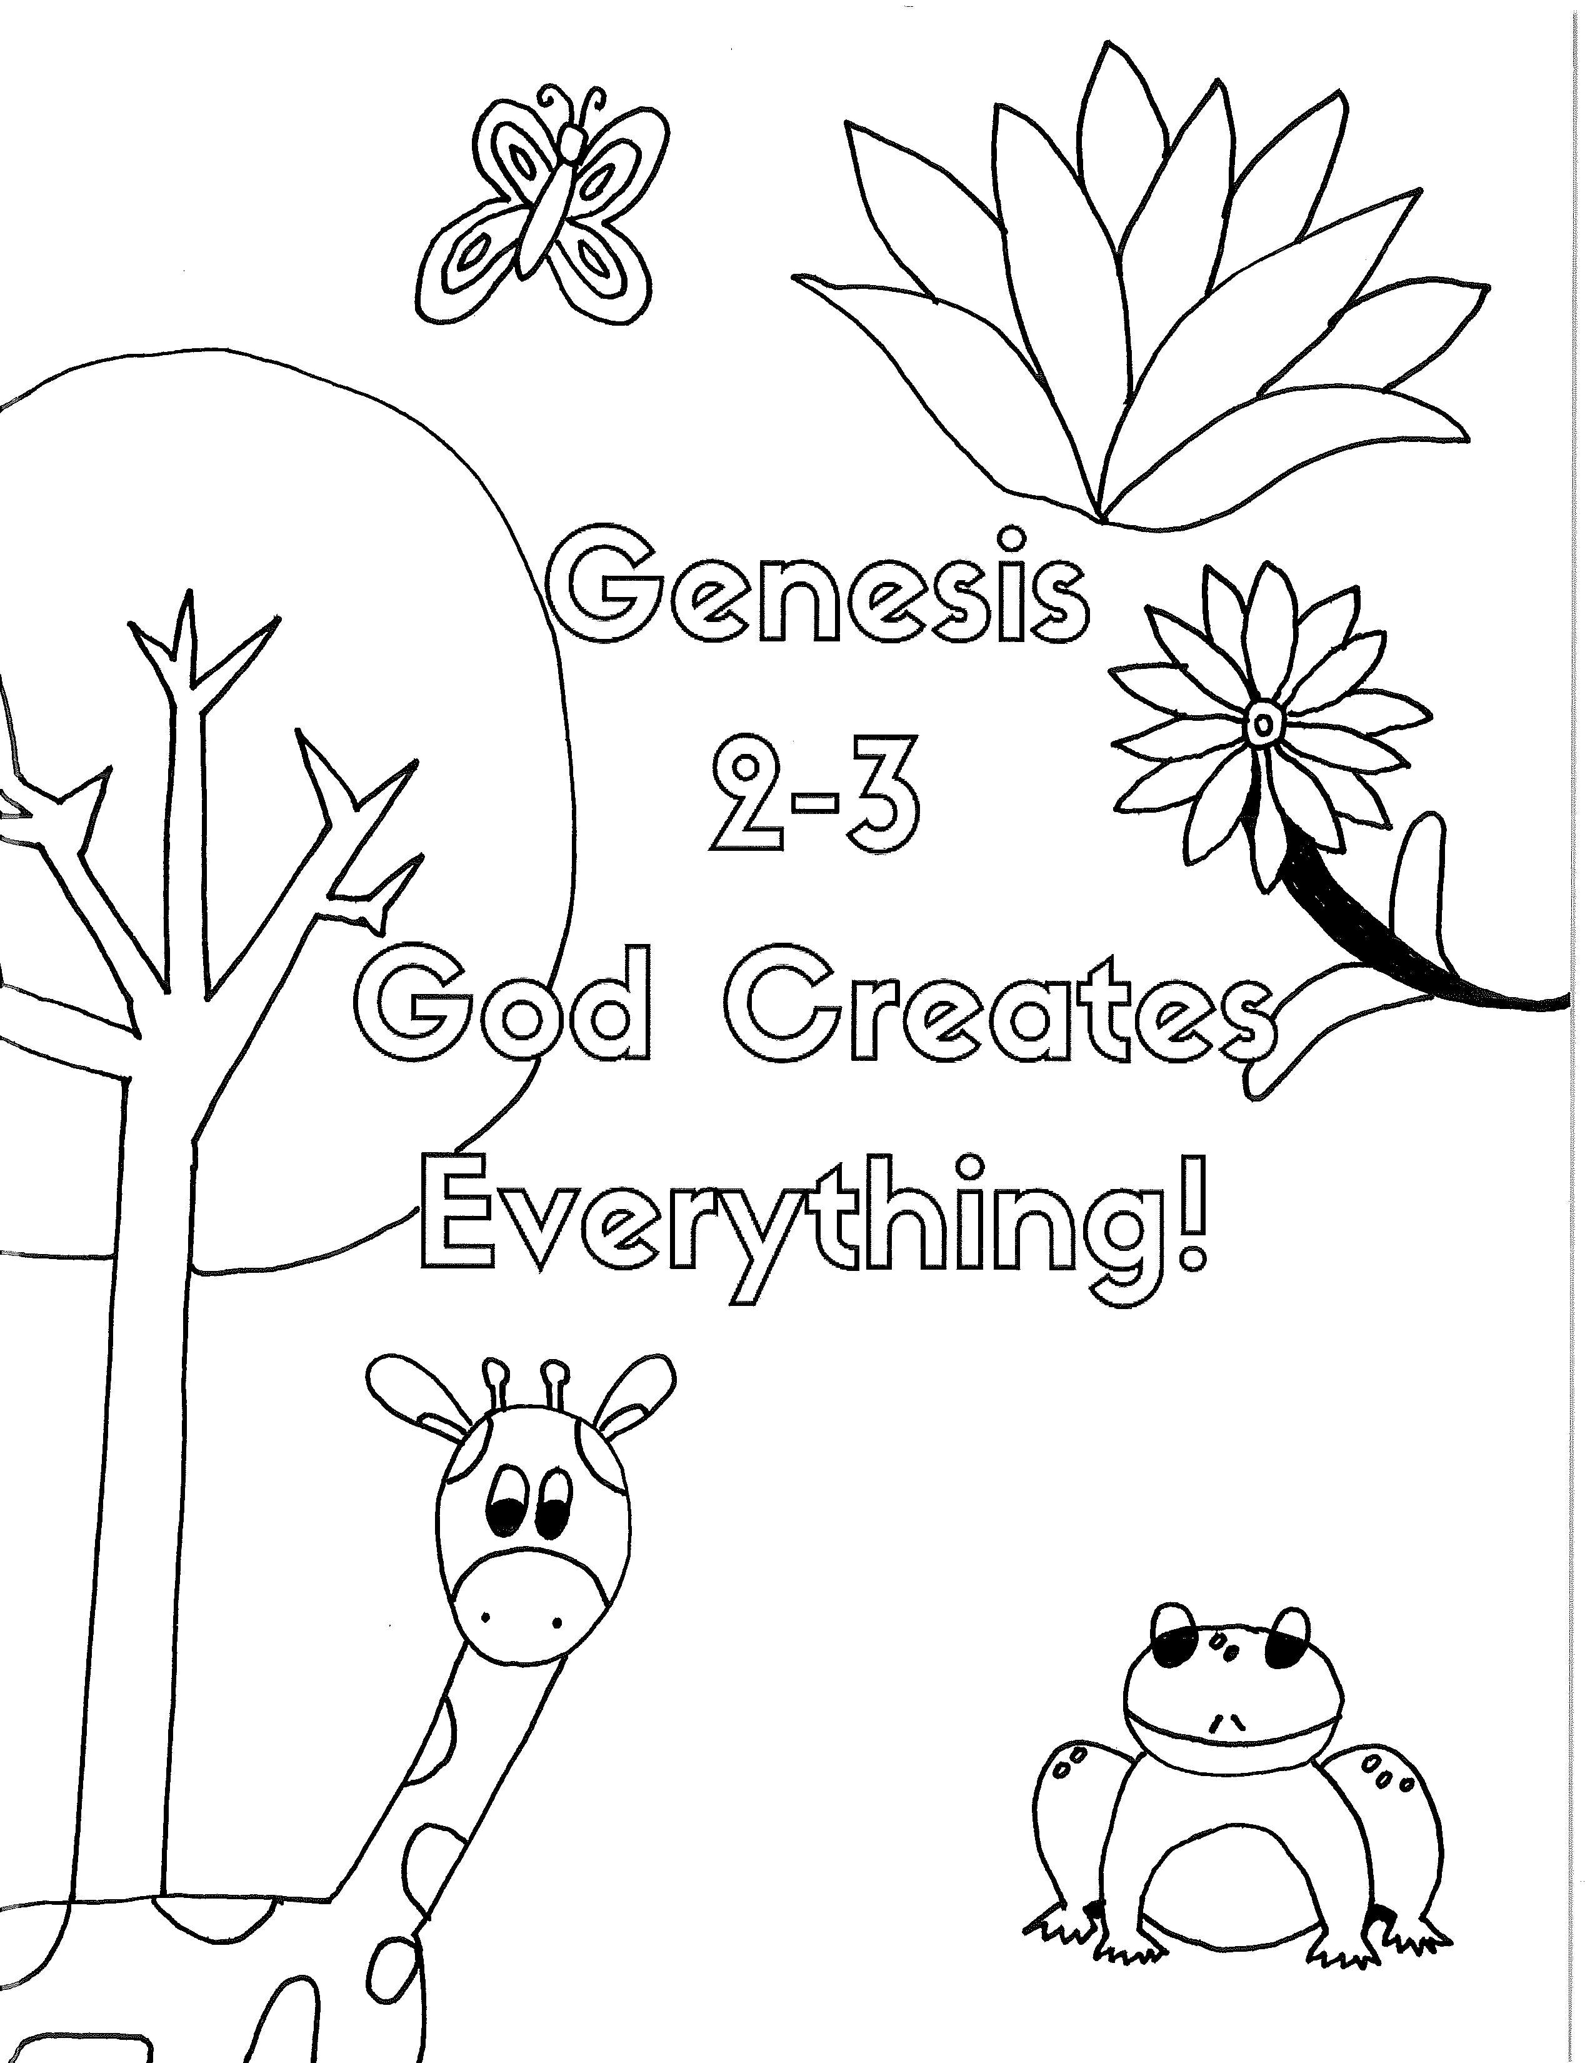
PLAY DUCK, DUCK, GOOSE
“God asked Adam and Eve to name all the creatures of the earth. Let’s play Duck, Duck, Goose, naming each person an animal name as you go around.”
To play, have kids sit in a circle with one person standing who is ‘it.’ Have them go around and tap each kid on the head as they give them an animal name (cat, elephant, rabbit). At some point they’ll name a kid ‘goose’ and that person will jump up and chase them around the circle. The one who was ‘it’ tries to make it around the circle and sit where the other was sitting before they tag them. The other person is now ‘it.’ If the person gets caught before sitting, they sit in the middle for a turn.

ANIMAL RACES

“God created you and me and our families and God also created all the different creatures of the earth. Let’s thank God for each of these animals by playing a game where we pretend to be them.”
​
Red Rover Version: If you have enough space, have everyone line up along one side of the room with a couple of ‘octopi’ in the middle. They’ll have their feet planted but can stretch out their arms as wide as they can to try to tag the other ‘creatures’ that go past them. If someone is tagged, they become an octopus in the spot they were tagged. Call out a color and say if anyone is wearing that color, they need to get to the other side without being tagged but to go across the room walking like a (different animal each time here). Examples of interesting animals would be: Penguins, turtles, tigers, orangutans, frogs, birds, crab, fish, elephants. You could do unique ones that are hard to mimic just to see what they come up with like a jellyfish. As soon as everyone is on the other side, start again. Go until everyone is an octopus.
Fast, Slow, Fast, Slow Version: If you have enough space, have all the kids line up on one side of the room. Explain that you’ll shout out either a ‘Cheetah!’ or a ‘Sloth!’ and they have to either run fast like a cheetah or slow like a sloth. Watch carefully because they have to change at the exact moment you call it. If anyone takes a few fast steps after you call out ‘sloth,’ they have to sit down. Make sure you only give them very short ‘cheetah’ bursts so they don’t run too far at once. Consider telling them they have to go the length of the room twice or three times or whatever makes sense for your space. Whoever is still in the game and makes it to the finish line first wins.

THE HIPPO SONG

This song was possibly done in large group if you have one. If it wasn't (or you don't do large group), you can teach it to your group. If you did it already, you can do it again if you'd like.
-You’ll have to go online to learn it

